CALL #: ____ | Date: ____
REPORT #: ____

SERVICE |  | CUSTOMER INFORMATION
INSTALLATION DATE: ____ |  | INSTALLATION SITE: ___________________________________
ENGINEER: ____ |  | ADDRESS: ___________________________________
 |  | COUNTRY: ___________________________________
 |  | DISTRIBUTOR NAME: ___________________________________
 |  | PHONE N°: ___________________________________
 |  | MAIL: ___________________________________

FOCAL ONE® IDENTIFICATION
1.1 | Focal One® serial number:  ____ | 1.2 | Probe 1 S/N:  ____ | 1.3 | Probe 2 S/N: ☐ NA  ____

SUBassemblies Serial number
N°§ | Item |  | Reference | Version* | Serial number*
2.1 | Amplifier |  | (R) 233360 | ___________ | ___________
 | Mot Probe Holder |  | (R) 901504 | ___________ | ___________
 | OR | IPO computer | (R) 236659 | ___________ | ___________
 |  | Ecrin computer | (R) 233176 | ___________ | ___________
 | Cooling system |  | (R) 901560 | ___________ | ___________
 | MEP board |  | (R) 235403 | ___________ | ___________
 | Extension board |  | (R) 228038 | ___________ | ___________
 | OR | Ultraview scanner | (R) 230885 | ___________ | ___________
 |  | EB2300 scanner | (R) 236150 | ___________ | ___________

*only for first form used or replacement.

CONTROL TOOLS
N°§ | TEST EQUIPEMENT | S/N | VALIDITY | COMMENTS
3.1 | Voltmeter | ___________ | ___________ | ___________
3.2 | Thermometer | ___________ | ___________ | ___________
3.3 | Inclinometer | ___________ | ___________ | ___________
3.4 | Current clamp | ___________ | ___________ | ___________
3.5 | Load bench | ___________ | ___________ | ___________

INSTALLATION SITE
N°§ | CONTROL | VALUE | PASS | FAIL | COMMENTS
4.1 | Conform to installation recommendations. |  | ☐ | ☐ | ___________
4.2 | UPS is present.  If YES, write its maxi power | ________  ☐ N/A | YES | NO | ___________
 |  |  | ☐ | ☐
4.3 | Circuit breaker (Type D or slow trip) is present.  Write the value | ________ | ☐ | ☐ | ___________
4.4 | Earth leakage circuit breaker is present.  Write the value | ________  (30mA) | ☐ | ☐ | ___________

FUSES
N°§ | CONTROL | PASS | FAIL | COMMENTS
5.1 | F1 and F2 are as expected | ☐ | ☐ | ___________
5.2 | F3 and F4 are as expected | ☐ | ☐ | ___________

MAIN FUNCTION
N°§ | CONTROL | PASS | FAIL | COMMENTS
6.1 | Secondary screen is enough compensated. | ☐ | ☐ | ___________
6.2 | Main screen movement. | ☐ | ☐ | ___________
6.3 | 3 positions of breaking pedal. | ☐ | ☐ | ___________
6.4 | Hexagon’s socket set screws. | ☐ | ☐ | ___________
6.5 | Cable wipers ☐ N/A if mobile system | ☐ | ☐ | ___________
6.6 | Tablet’s locking system. | ☐ | ☐ | ___________
6.7 | Tablet displacement. | ☐ | ☐ | ___________
6.8 | Screens movements. | ☐ | ☐ | ___________
6.9 | Main power cable. | ☐ | ☐ | ___________
6.10 | Ablasonic holder tightening. | ☐ | ☐ | ___________
6.11 | Mönninghoff arm’s locking system. | ☐ | ☐ | ___________
6.12 | Chassis fans. | ☐ | ☐ | ___________

MANUAL MOVEMENTS.
N°§ | CONTROL | VALUE | PASS | FAIL | COMMENTS
7.1 | No hard point during displacement. |  | ☐ | ☐ | ___________
7.2 | Move manually from one side to another.  Record distances: | - X = ____  (235mm ±3)  - Y = ____  (50mm ±3) | ☐  ☐ | ☐  ☐ | ___________
7.3 | No friction between cover and shutter. |  | ☐ | ☐ | ___________
7.4 | No cables can interfere with movements. |  | ☐ | ☐ | ___________
7.5 | Probe holder levelled | •X = ____  •Y = ____ | ☐ | ☐ | ___________

Focal One® switch on.
N°§ | CONTROL | VALUE | PASS | FAIL | COMMENTS
8.1 | Blue LED’s. |  | ☐ | ☐ | ___________
8.2 | Switch ON Focal One®, all the auto start is executed. |  | ☐ | ☐ | ___________
8.3 | Check powers supplies :  - Before F1 and after F2  - Before F3 and after F4  - MEP power supply  - 12V power supply | - ___ V (Main power ±10%)  - ___ V (217V -253V)  - ___ V (22.8V - 25.2V)  - ___ V (11.4V – 12.6V) | ☐  ☐  ☐  ☐ | ☐  ☐  ☐  ☐ | ___________
8.4 | LED tape. |  | ☐ | ☐ | ___________
8.5 | Patient movement detector. |  | ☐ | ☐ | ___________
8.6 | External USB connectors. |  | ☐ | ☐ | ___________
8.7 | Touchpad test |  | ☐ | ☐ | ___________
8.8 | All “Get Init Status” are “OK” |  | ☐ | ☐ | ___________
8.9 | MEP Analog inputs :  “In7 - 3.3 Volts Power Supply”  “In8 - 24 Volts Power Supply” | ___________ (3.13V-3.47V) ___________ (22.8V-25.2V) | ☐  ☐ | ☐  ☐ | ___________
8.10 | Inspect “Error” file. |  | ☐ | ☐ | ___________
8.11 | Emergency stop functions |  | ☐ | ☐ | ___________

PROBE HOLDER ARM.
N°§ | CONTROL | VALUE | PASS | FAIL | COMMENTS

ALL AXIS
9.1.1 | Status is “NoMotError” after centering. |  | ☐ | ☐ | ___________
9.1.2 | 4 values of “Pos Mot” are 0mm (± 0.2mm) | X: ___________  Y: ___________  T: ___________ | ☐ | ☐ | ___________
9.1.3 | Record backlash values | X: ___________  Y: ___________  T: ___________
9.1.4 | The keypad works well. |  | ☐ | ☐ | ___________
9.1.5 | Theta fan works. |  | ☐ | ☐ | ___________

X AXIS (LONGITUDINAL)
N°§ | CONTROL | VALUE | PASS | FAIL | COMMENTS
9.2.1 | Measure the complete displacement from +50mm to -50mm.
 | Software value:  Measured value: | ___ mm (100 mm)  ___ mm (<2mm) | ☐ | ☐ | ______________________________

Y AXIS (TRANSVERSAL)
N°§ | CONTROL | VALUE | PASS | FAIL | COMMENTS
9.3.1 | Measure the complete displacement from +25mm to -25mm.
 | Software value:  Measured value: | ___ mm (50 mm)  ___ mm (<2mm) | ☐ | ☐ | ______________________________

Z AXIS (ACTUATOR)
N°§ | CONTROL | VALUE | PASS | FAIL | COMMENTS
9.4.1 | Measure the complete displacement from +40mm to -40mm.
 | Software value:  Measured value: | ___ mm (80 mm)  ___ mm (<2mm) | ☐ | ☐ | ______________________________

Θ AXIS (THETA)
N°§ | CONTROL | VALUE | PASS | FAIL | COMMENTS
9.5.1 | Request a movement of +70°. Measure displacement. |  |  |  | ______________________________
 | Software value:  Measured value: | ___°  ___° (<2°) | ☐ | ☐ | ______________________________

MANUAL MOVEMENTS
N°§ | CONTROL |  | PASS | FAIL | COMMENTS
9.6.1 | Front right, No interferences between motors board cables and frame. No collision with cover. |  | ☐ | ☐ | ______________________________
9.6.2 | Back right No interferences between motors board cables and frame. No collision with cover. |  | ☐ | ☐ | ______________________________
9.6.3 | Back left No interferences between motors board cables and frame. No collision with cover. |  | ☐ | ☐ | ______________________________
9.6.4 | Front left No interferences between motors board cables and frame. No collision with cover. |  | ☐ | ☐ | ______________________________
9.6.5 | No friction with top cover |  | ☐ | ☐ | ______________________________

RANDOM MOVEMENTS
N°§ | CONTROL | VALUE | PASS | FAIL | COMMENTS
9.7.1 | No motors errors occur after mechanical origin. |  | ☐ | ☐ | ______________________________
9.7.2 | Record backlash values before random:  X = ___________ (<0.3mm) / Y = ___________ (<0.3mm) / T = ___________(<0,6°)
9.7.3 | Time start : ___________  Time stop : ___________  Number of movements : ___________
9.7.4 | Open file and check if there is no error during displacement. |  | ☐ | ☐ | ______________________________
9.7.5 | No motors errors occurs after mechanical origin |  | ☐ | ☐ | ______________________________
9.7.6 | Record backlash values before random:  X = ___________ (<0.3mm) / Y = ___________ (<0.3mm) / T = ___________(<0,6°)
9.7.7 | Difference between before and after random |  | ☐ | ☐ | ______________________________

cooling system.
N°§ | CONTROL | VALUE | PASS | FAIL | COMMENTS
10.1 | Peltier consumption. | Max: ___A  (27-38A) | ☐ | ☐ |  | ______________________________
10.2 | Fans operate and cooling temperature decreases. |  | ☐ | ☐ |  | ______________________________
10.3 | Pump operates. |  | ☐ | ☐ |  | ______________________________
10.4 | Regulation is working. |  | ☐ | ☐ |  | ______________________________
10.5 | Peltier consumption. | ___ A (<0.2A) | ☐ | ☐ |  | ______________________________
10.6 | Difference between the two PT100. | ___ °C.(<2°C) | ☐ | ☐ |  | ______________________________
10.7 | Difference between thermometer and mean. | ___ °C.(<4.5°C) | ☐ | ☐ |  | ______________________________
10.8 | Cooling’s fans. |  | ☐ | ☐ |  | ______________________________

ultrasound.
11.1 | 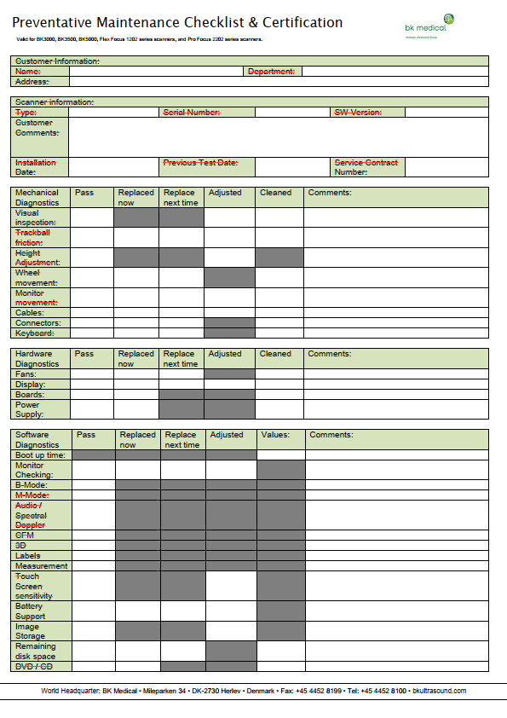
11.1 | 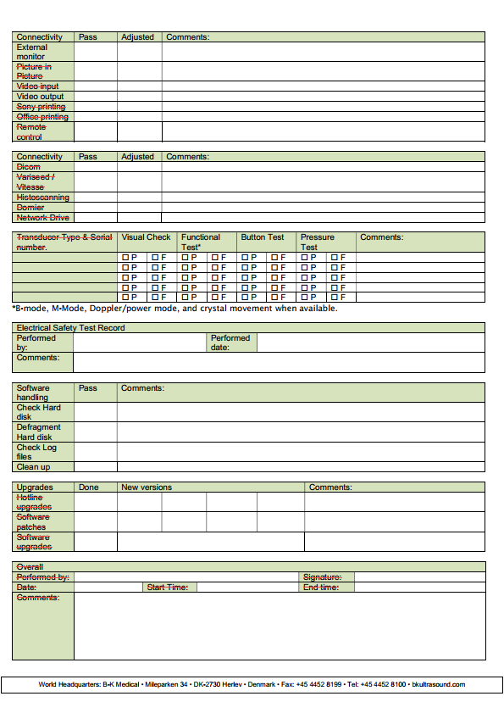
N°§ | CONTROL |  | VALUE |  |  | PASS | FAIL | COMMENTS
11.2 | Fans function. |  |  |  |  | ☐ | ☐ | ______________________________
11.3 | IP address  Port number |  | ___________  ___________ |  |  | ______________________________
11.4 | Delay |  | ON: ___ s (100s)  OFF: ___s (30s) |  |  | ☐  ☐ | ☐  ☐ | ______________________________
11.5 | Offset |  | X: ___________  Y: ___________ |  |  | ______________________________
11.6 | Size |  | X: ___________  Y: ___________ |  |  | ______________________________
11.7 | Ultrasound imaging appears |  |  |  |  | ☐ | ☐ | ______________________________
11.8 | Yellow box |  |  |  |  | ☐ | ☐ | ______________________________
11.9 | Active area |  |  |  |  | ☐ | ☐ | ______________________________
11.10 | Exclusion circle coordinates |  |  | X: ___ mm  Y: ___ mm  Radius: ___ mm |  | ______________________________
11.11 | Screen image is correctly oriented |  |  |  |  | ☐ | ☐ | ______________________________
11.12 | Date and time are correct. |  |  |  |  | ☐ | ☐ | ______________________________
Parameter checking |  | Ultraview |  |  | EB2300
11.13 | Size | (75%) |  |  |  | ☐ | ☐ | ______________________________
 | Dyn Range | (62dB) |  |  |  | ☐ | ☐ | ______________________________
 | Pers | (1) |  |  |  | ☐ | ☐ | ______________________________
 | Resolution: | Only 1 focal point at 25mm. |  |  |  | ☐ | ☐ | ______________________________
 | Depth | (7.8 or 8cm) |  |  |  | ☐ | ☐ | ______________________________
 | Frequency | (7.5MHz) |  |  |  | ☐ | ☐ | ______________________________
 | Imaging cell | (6030) |  |  | (X12C3E) | ☐ | ☐ | ______________________________
 | Mi | (1.39/1.50) |  |  | (1.2/1.2) | ☐ | ☐ | ______________________________
 | Gain | (50%) |  |  |  | ☐ | ☐ | ______________________________
 | TIS | (0.3/4.0Hz) |  |  |  | ☐ | ☐ | ______________________________

probe parameters.
12.1 | Probe serial number | ___________ | ______________________________
N°§ | CONTROL | VALUE | PASS | FAIL | N/A | COMMENTS
12.2 | Power connector VPC. |  | ☐ | ☐ |  | ___________
12.3 | Ultrasound connector. |  | ☐ | ☐ |  | ___________
12.4 | Probe adapts correctly. |  | ☐ | ☐ |  | ___________
12.5 | Holding pin. |  | ☐ | ☐ |  | ___________
12.6 | Luer connections. |  | ☐ | ☐ |  | ___________
12.7 | Correspondence between software and data sheet. |  | ☐ | ☐ |  | ___________
12.8 | Record “Installation date”. | ___ | ☐ | ☐ |  | ___________
12.9 | Total number of shots. | ___ | ☐ | ☐ |  | ___________
12.10 | Total number of treatments. | ___ | ☐ | ☐ |  | ___________
12.11 | Last maintenance date. | ___ | ☐ | ☐ | ☐ | ___________
12.12 | Nb of Shots since last maintenance. | ___ | ☐ | ☐ | ☐ | ___________
12.13 | Nb of Treatments since last maintenance. | ___ | ☐ | ☐ | ☐ | ___________
12.14 | “Calibration state” is “Done”. |  | ☐ | ☐ |  | ___________

Power
N°§ | CONTROL | VALUE | PASS | FAIL | COMMENTS
13.1 | Record amplifier serial number | ___________ | ☐ | ☐ | ______________________________
13.2 | Record COM number | ___________ | ☐ | ☐ | ______________________________
13.3 | Fans consumption | ___ A  (2.37A - 2.63A) | ☐ | ☐ | ______________________________
13.4 | All wires are connected. |  | ☐ | ☐ | ______________________________
13.5 | Writes totals values on this table.  Firing number Focal Watts per channel Total of watts Total of Watts into “Pact_Load (W)” columns  1 32 1 16 ___________  2 37 2 32 ___________  3 42 3 48 ___________  4 47 4 64 ___________  5 52 5 80 ___________  6 57 6 96 ___________  7 62 7 112 ___________  8 67 8 128 ___________  9 72 9 144 ___________  10 NAT 10 160 ___________
13.6 | Shoots are into tolerances. There is no red values |  | ☐ | ☐ | ______________________________

3D MEASUREMENT AND RECTUM WALL SIMULATION WITH DUMMY LOAD
N°§ | CONTROL | VALUE | PASS | FAIL | COMMENTS
14.1 | X real  X measured | ___ mm  ___ mm(<2 mm) | ☐ | ☐ | ______________________________
14.2 | Y real  Y measured | ___ mm  ___ mm(<2 mm) | ☐ | ☐ | ______________________________
14.3 | Z real  Z measured | ___ mm  ___ mm(<2 mm) | ☐ | ☐ | ______________________________
14.4 | Software detects rectum automatically. |  | ☐ | ☐ | ______________________________
14.5 | Transverse corrections occur. |  | ☐ | ☐ | ______________________________
14.6 | Treatment doesn’t stop after correction. |  | ☐ | ☐ | ______________________________
14.7 | Software gives error message. |  | ☐ | ☐ | ______________________________

treatment simulation.
N°§ | CONTROL | VALUE | PASS | FAIL | COMMENTS
15.1 | Initialization done without message |  | ☐ | ☐ | ______________________________
15.2 | Motors centering done |  | ☐ | ☐ | ______________________________
15.3 | Fusion test |  | ☐ | ☐ | ______________________________
For the 4 first Block
15.4 | Treatment area is correctly defined. |  | ☐ | ☐ | ______________________________
15.5 | Lesions are correctly displayed. |  | ☐ | ☐ | ______________________________
15.6 | Endo-rectal probe moves to the next slice. |  | ☐ | ☐ | ______________________________
15.7 | Localization process is successfully completed. |  | ☐ | ☐ | ______________________________
15.8 | Endo-rectal probe moves from lesion to lesion. |  | ☐ | ☐ | ______________________________
15.9 | Treatment area is successfully completed. |  | ☐ | ☐ | ______________________________
For the 4 last Block
15.10 | Treatment area is correctly defined. |  | ☐ | ☐ | ______________________________
15.11 | Lesions are correctly displayed. |  | ☐ | ☐ | ______________________________
15.12 | Endo-rectal probe moves to the next slice. |  | ☐ | ☐ | ______________________________
15.13 | Localization process is successfully completed. |  | ☐ | ☐ | ______________________________
15.14 | Endo-rectal probe moves from lesion to lesion. |  | ☐ | ☐ | ______________________________
15.15 | Treatment area is successfully completed. |  | ☐ | ☐ | ______________________________
For the end of treatment
15.16 | Print treatment report. |  | ☐ | ☐ | ______________________________
15.17 | Treatment duration |  | __________ |  | ______________________________

DISCONNECT THE MAIN PROBE AND CONNECT THE SECOND PROBE IF IT IS AVAILABLE.

IF NOT, TICK THIS BOX: ☐.

THEN PERFORM THE SAME TESTS AS PREVIOUSLY.

probe parameters.
12.1 |  | Probe serial number | ___________ | ______________________________
N°§ |  | CONTROL | VALUE | PASS | FAIL | N/A | COMMENTS
12.2 |  | Power connector VPC. |  | ☐ | ☐ |  | ___________
12.3 |  | Ultrasound connector. |  | ☐ | ☐ |  | ___________
12.4 |  | Probe adapts correctly. |  | ☐ | ☐ |  | ___________
12.5 |  | Holding pin. |  | ☐ | ☐ |  | ___________
12.6 |  | Luer connections. |  | ☐ | ☐ |  | ___________
12.7 |  | Correspondence between software and data sheet. |  | ☐ | ☐ |  | ___________
12.8 |  | Record “Installation date”. | ___ | ☐ | ☐ |  | ___________
12.9 |  | Total number of shots. | ___ | ☐ | ☐ |  | ___________
12.10 |  | Total number of treatments. | ___ | ☐ | ☐ |  | ___________
12.11 |  | Last maintenance date. | ___ | ☐ | ☐ | ☐ | ___________
12.12 |  | Nb of Shots since last maintenance. | ___ | ☐ | ☐ | ☐ | ___________
12.13 |  | Nb of Treatments since last maintenance. | ___ | ☐ | ☐ | ☐ | ___________
12.14 |  | “Calibration state” is “Done”. |  | ☐ | ☐ |  | ___________

Power
N°§ | CONTROL | VALUE | PASS | FAIL | COMMENTS
13.1 | Record amplifier serial number | ___________ | ☐ | ☐ | ______________________________
13.2 | Record COM number | ___________ | ☐ | ☐ | ______________________________
13.3 | Fans consumption | ___ A  (2.37A - 2.63A) | ☐ | ☐ | ______________________________
13.4 | All wires are connected. |  | ☐ | ☐ | ______________________________
13.5 | Write total values on this table.  Firing number Focal Watts per channel Total of watts Total of Watts into “Pact_Load (W)” columns  1 32 1 16 ___________  2 37 2 32 ___________  3 42 3 48 ___________  4 47 4 64 ___________  5 52 5 80 ___________  6 57 6 96 ___________  7 62 7 112 ___________  8 67 8 128 ___________  9 72 9 144 ___________  10 NAT 10 160 ___________
13.6 | Shoots are into tolerances. There is no red values |  | ☐ | ☐ | ______________________________

3D MEASUREMENT AND RECTUM WALL SIMULATION WITH DUMMY LOAD
N°§ | CONTROL | VALUE | PASS | FAIL | COMMENTS
14.1 | X real  X measured | ___ mm  ___ mm(<2 mm) | ☐ | ☐ | ______________________________
14.2 | Y real  Y measured | ___ mm  ___ mm(<2 mm) | ☐ | ☐ | ______________________________
14.3 | Z real  Z measured | ___ mm  ___ mm(<2 mm) | ☐ | ☐ | ______________________________
14.4 | Software detects rectum automatically. |  | ☐ | ☐ | ______________________________
14.5 | Transverse corrections occur. |  | ☐ | ☐ | ______________________________
14.6 | Treatment doesn’t stop after correction. |  | ☐ | ☐ | ______________________________
14.7 | Software gives error message. |  | ☐ | ☐ | ______________________________

treatment simulation.
N°§ | CONTROL | VALUE | PASS | FAIL | COMMENTS
15.1 | Initialization done without message |  | ☐ | ☐ | ______________________________
15.2 | Motors centering done |  | ☐ | ☐ | ______________________________
15.3 | Fusion test |  | ☐ | ☐ | ______________________________
For the 4 first Block
15.4 | Treatment area is correctly defined. |  | ☐ | ☐ | ______________________________
15.5 | Lesions are correctly displayed. |  | ☐ | ☐ | ______________________________
15.6 | Endo-rectal probe moves to the next slice. |  | ☐ | ☐ | ______________________________
15.7 | Localization process is successfully completed. |  | ☐ | ☐ | ______________________________
15.8 | Endo-rectal probe moves from lesion to lesion. |  | ☐ | ☐ | ______________________________
15.9 | Treatment area is successfully completed. |  | ☐ | ☐ | ______________________________
For the 4 last Block
15.10 | Treatment area is correctly defined. |  | ☐ | ☐ | ______________________________
15.11 | Lesions are correctly displayed. |  | ☐ | ☐ | ______________________________
15.12 | Endo-rectal probe moves to the next slice. |  | ☐ | ☐ | ______________________________
15.13 | Localization process is successfully completed. |  | ☐ | ☐ | ______________________________
15.14 | Endo-rectal probe moves from lesion to lesion. |  | ☐ | ☐ | ______________________________
15.15 | Treatment area is successfully completed. |  | ☐ | ☐ | ______________________________
For the end of treatment
15.16 | Print treatment report. |  | ☐ | ☐ | ______________________________
15.17 | Treatment duration |  | __________ |  | ______________________________

COMPUTER
N°§ | CONTROL | VALUE | PASS | FAIL | N/A | COMMENTS
16.1 | PC screens image |  | ☐ | ☐ |  | ___________
16.2 | Free space on HDD | C: ___ (>10GB)  D: ___ (>10GB) | ☐  ☐ | ☐  ☐ |  | ___________
16.3 | Number of patients treated since last maintenance  activity. | ___________ | ☐ | ☐ | ☐ | ___________
16.4 | Indicate date of last maintenance activity on this machine. | ___________ | ☐ | ☐ | ☐ | ___________
16.5 | Defrag analysis. |  | ☐ | ☐ | ☐ | ___________
16.6 | Date and time. |  | ☐ | ☐ |  | ___________
16.7 | Software version Check |  | ☐ | ☐
16.8 | Files backup and retrieve |  | ☐ | ☐ | ☐
16.9 | Printer test. |  | ☐ | ☐ | ☐
16.10 | Back up battery. | ___ V | ☐ | ☐ | ☐ | ___________
16.11 | Clean computer dust filter. |  | ☐ | ☐ |  | ___________

ASPECT AND ACCESSORIES
N°§ | CONTROL | PASS | FAIL | N/A | COMMENTS
17.1 | Wheels don’t touch covers or chassis. | ☐ | ☐ |  | ___________
17.2 | Panels are in good condition | ☐ | ☐ |  | ___________
17.3 | Long panels are easily removed. | ☐ | ☐ |  | ___________
17.4 | Labels are in good condition | ☐ | ☐ |  | ___________
17.5 | Ground cables are firmly attached to panels. | ☐ | ☐ | ☐ | ___________
17.6 | Leg holder condition. | ☐ | ☐ |  | ___________
17.7 | Transport carriage condition. | ☐ | ☐ | ☐ | ___________
17.8 | Covers condition. | ☐ | ☐ |  | ___________
17.9 | Maintenance sticker. | ☐ | ☐ | ☐ | ___________

ELECTRICAL SAFETY TEST
N°§ | CONTROL | PASS | FAIL | N/A | COMMENTS
18.1 | All item passed in electrical safety test | ☐ | ☐ | ☐ | ___________

reporting
N°§ | CONTROL | PASS | FAIL | N/A | COMMENTS
19.1 | Reporting in Website support | ☐ | ☐ | ☐ | ___________

DOCUMENTS
List any documents left with customer or local distributor.
____________________________________________________________________________________________________
____________________________________________________________________________________________________
____________________________________________________________________________________________________
____________________________________________________________________________________________________
____________________________________________________________________________________________________

Date: __/__/__ | Date: __/__/__ | Date: __/__/__
Signature: | Signature: | Signature:
CUSTOMER:  ____________________________ | SUPPORT ENGINEER:  ____________________________ | SERVICE MANAGER:  ____________________________

