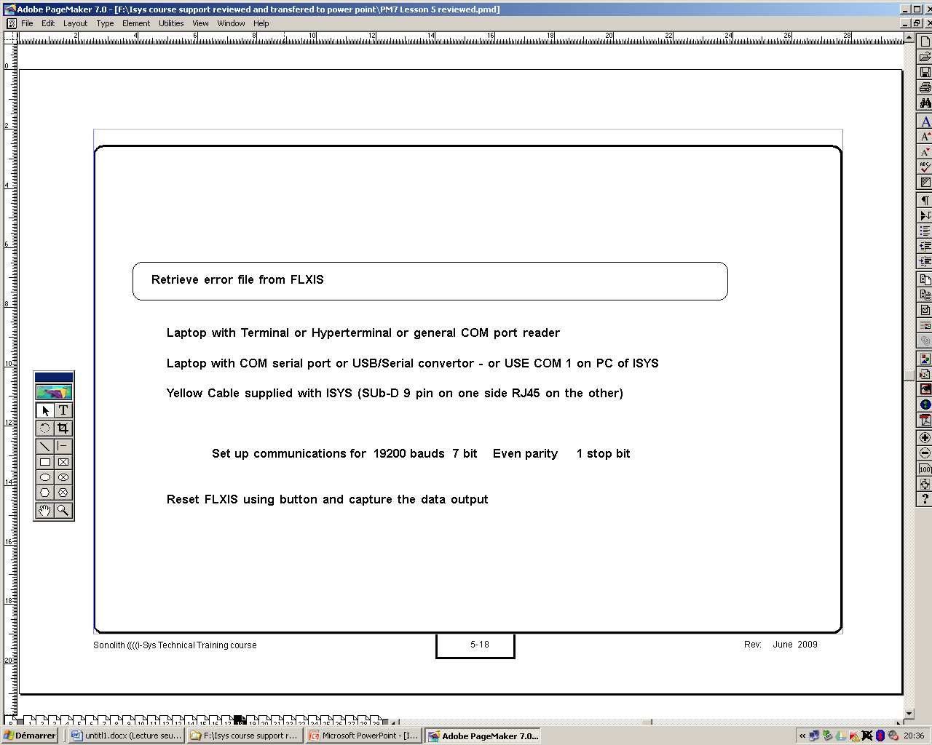

Hypertherminal setting to communicate with the Flexis on the control board RJ45 -X4-