Dear Sirs,

Next week we will install the Dicom option on the ISYS lithotriptor. In order to save time, I would like to inform you that the ISYS AETitle will be: **SONOLITHISYS.**

We will need to set different parameters so that our computer can communicate with your server. That is to say:

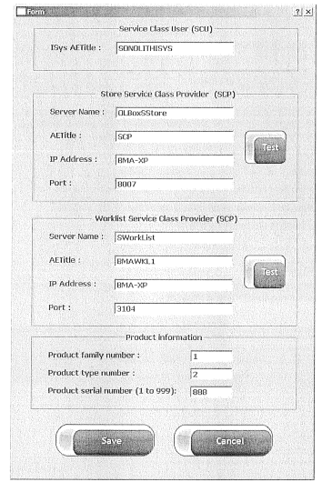

To be detailed so that we can communicate with the server

We would appreciate very much if the parameters to be detailed (See above) could be available for the installation of the Dicom on our lithotripter, upon our arrival.

Finally a **worklist** **should be available** so that we can test ultimately the Dicom when the Dicom settings will be completed.

Best regards and looking forwards to meeting you soon,

Denis CHARLET