|  |  |
| --- | --- |
|  | Checking-List 502 Touch Step 2 |

|  |  |  |  |  |  |  |  |  |
| --- | --- | --- | --- | --- | --- | --- | --- | --- |
| REF. DOCUMENT : | | QF 220 | | | | | | |
|  | | Nom | | | Fonction | Date | | Signature |
| AUTEUR | | Nicolas SOLLIER | | | Technicien SAV |  | |  |
| VERIFICATEUR | | Nathalie LUONG | | | Chargée Qualité |  | |  |
| APPROBATEUR | | Olivier BOSCHAT | | | Responsable SAV |  | |  |
|  | | | | | | | | |
| DIFFUSION : | | | | ECHOSENS, DISTRIBUTEURS | | | | |
|  | | | | | | | | |
| MODIFICATIONS : | | | | | | | | |
| Date | Indice | | Nature de la modification | | | | Par | |
| 15/06/2017 | 1 | | Création du document | | | | OB | |
| 16/01/2018 | 2 | | Ajout des Technical Note à appliquer lors des maintenances préventives  Ajout de la partie « Probe 3 »  Ajout d’une cartouche de signature à la fin du rapport | | | | NSO | |
|  |  | |  | | | |  | |

|  |  |  |
| --- | --- | --- |
| Form REF. | QF220.2_SOP QP052 | 3 pages |

|  |  |  |  |  |
| --- | --- | --- | --- | --- |
| **Product Informations** | | | | |
| **S/N** |  | **Man. /Dist.** |  | |
| **Probe S/N** |  |  | |  |
| **Customer location** |  | **Customer name** |  | |

|  |  |  |  |
| --- | --- | --- | --- |
| **Service location** | Echosens  On site ………………………………  Other:…………………………….. | | |
| **Service date** |  | **Service reference** | SR/ |

|  |  |
| --- | --- |
| **Technical Note Applicable** | |
| 27-Main Filter Enhancement | OK  NOT OK Comment: |

|  |  |  |
| --- | --- | --- |
| **Software** | | |
| Update software | OK  NOT OK  N/A | Software version = |
| Check Log files | OK  NOT OK | |
| Check import/export data | OK  NOT OK | |
| Check of Excel backup | OK  NOT OK | |

|  |  |  |  |  |
| --- | --- | --- | --- | --- |
| **Used instruments** | | | | |
| **Manufacturer** | **Model** | **Description** | **MET (Echosens only)**  **Or S/N (for distributors)** | **Calibration due date** |
|  |  |  |  |  |
|  |  |  |  |  |

|  |  |  |
| --- | --- | --- |
| **Computer Area** | | |
| **Mother board AIMB-223 voltage, connector CN19** | | |
| **Connector description** | **Value obtained** | **Results** |
| Between pin 1 and 3: + 12 Vdc ±0,50Vdc |  | OK NOT OK |
| Between pin 2 and 4: + 12 Vdc ±0,50Vdc |  | OK NOT OK |
| Check of the connectors | OK NOT OK | |
| Disk drive test | OK NOT OK | |

|  |  |  |  |
| --- | --- | --- | --- |
| **Power Supply Area** | | | |
| **LAMBDA NV 75 POWER MODULE J1 OUTPUT CONNECTOR (to be measured FS ON)** | | | |
| **Connector description** | | **Value obtained** | **Results** |
| Between Pin 10 and 20: + 05 Vdc ±0,50Vdc | |  | OK NOT OK |
| Between Pin 06 and 03: + 12 Vdc ±0,50Vdc | |  | OK NOT OK |
| Between Pin 07 and 04: + 12 Vdc ±0,50Vdc | |  | OK NOT OK |
| Between Pin 08 and 13: + 12 Vdc ±0,50Vdc | |  | OK NOT OK |
| Between Pin 16 and 14: + 12 Vdc ±0,50Vdc | |  | OK NOT OK |
| Main filter | OK NOT OK | Fuses (2A/250V)*2 | OK NOT OK |

|  |  |  |  |  |  |  |  |
| --- | --- | --- | --- | --- | --- | --- | --- |
| **Elastometry V2 Area** | | | | | | | |
| **Connector description** | | | | **Value obtained** | **Results** | | |
| Pin 5 : + 12 Vdc ±0,50Vdc | | | |  | OK  NOT OK | | |
| Pin 6 : + 12 Vdc ±0,50Vdc | | | |  | OK  NOT OK | | |
| Check green LED on MONOACQ | | | | | OK  NOT OK | | |
| Check connection | | | | | OK  NOT OK | | |
| **Screen Area** | | | | | | | |
| Test on/off button (led on) | | | OK  NOT OK | | | | |
| Check the Touchpad | | | OK  NOT OK | | | | |
| Test VGA output | | | OK  NOT OK  N/A | | | | |
| Test USB port | Front | | OK  NOT OK Comment: | | | | |
| Rear | | OK  NOT OK Comment: | | | | |
| Test network output | | | OK  NOT OK  N/A | | | | |
| Test of printer | | | OK  NOT OK  N/A | | | | |
|  | |  | | | |  | |
| **Probe 1** | | | | | | | |
| Blue LEDS of the probe | | | | OK  NOT OK | | | |
| Check the probe memory | | | | Date of next calibration :……...……... | | | OK  NOT OK |
| Acquisition Test | | | | OK  NOT OK | | | |
| Check the information contact on calibration message | | | | OK  NOT OK | | | |

|  |  |  |
| --- | --- | --- |
| **Probe 2**  **N/A** | | |
| Blue LEDS of the probe | OK  NOT OK | |
| Check the probe memory | Date of next calibration :……...……... | OK  NOT OK |
| Acquisition Test | OK  NOT OK | |
| Check the information contact on calibration message | OK  NOT OK | |

|  |  |  |
| --- | --- | --- |
| **Probe 3**  **N/A** | | |
| Blue LEDS of the probe | OK  NOT OK | |
| Check the probe memory | Date of next calibration :……...……... | OK  NOT OK |
| Acquisition Test | OK  NOT OK | |
| Check the information contact on calibration message | OK  NOT OK | |

|  |  |
| --- | --- |
| **Class 1 Type B safety test** | |
| Date………………  Tested By……………….…..…… | Protective earth impedance = (Earth bond)  < 0,3Ω  Pass     Fail  Earth leakage current (Equipment leakage)  <500µA  Pass     Fail  Breakdown on insulation(insulation EUT 500V)   Pass     Fail |
|  | |
| IEC 62353:2008 | |

|  |  |
| --- | --- |
| **FRAME** | |
| State of device(cf. picture below) | OK  NOT OK |
| Labelling | OK  NOT OK |

**FRAME CONTROL**

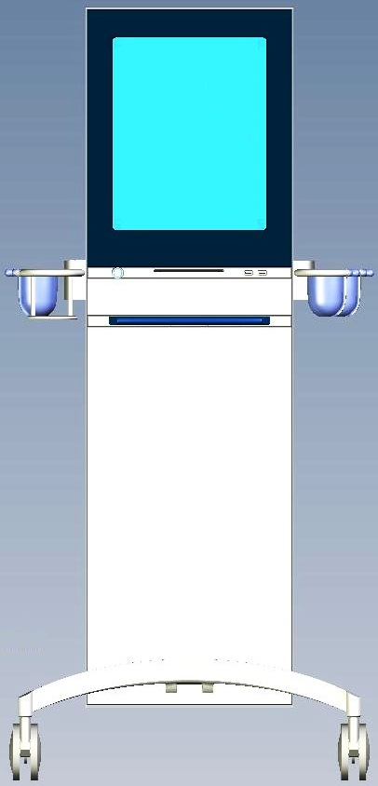

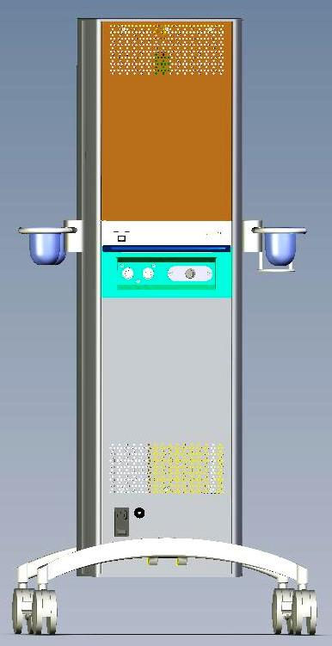

|  |  |
| --- | --- |
| Operator Code: | Signature: |