|  |  |
| --- | --- |
|  | Checking-List 402 |

|  |  |  |  |  |  |  |  |  |
| --- | --- | --- | --- | --- | --- | --- | --- | --- |
| REF. DOCUMENT : | | QF 145 | | | | | | |
|  | | Nom | | | Fonction | Date | | Signature |
| AUTEUR | | Nicolas SOLLIER | | | Technicien SAV |  | |  |
| VERIFICATEUR | | Nathalie LUONG | | | Chargée Qualité |  | |  |
| APPROBATEUR | | Olivier BOSCHAT | | | Responsable SAV |  | |  |
|  | | | | | | | | |
| DIFFUSION : | | | | ECHOSENS, DISTRIBUTEURS | | | | |
|  | | | | | | | | |
| MODIFICATIONS : | | | | | | | | |
| Date | Indice | | Nature de la modification | | | | Par | |
| 11/12/13 | 1 | | Création du document | | | | KC | |
| 09/11/15 | 2 | | Mise à jour des incertitudes de mesure pour harmonisation avec le manuel technique  Mise à jour de l’adresse | | | | KC | |
| 15/06/2017 | 3 | | Ajout valeurs test électrique | | | | OB | |
| 02/10/2017 | 4 | | Remise en forme des informations produit  Remise en forme du tableau « Used instruments »  Ajout des parties « Probe 2 »  Ajout d’une cartouche de signature à la fin du rapport | | | | NSO | |

|  |  |  |
| --- | --- | --- |
| Form REF. | QF145.4_SOP QP052 | 3 pages |

|  |  |  |  |  |
| --- | --- | --- | --- | --- |
| **Product Information** | | | | |
| **S/N** |  | **Man. /Dist.** |  | |
| **Probe S/N** |  |  | |  |
| **Customer location** |  | **Customer name** |  | |

|  |  |  |  |
| --- | --- | --- | --- |
| **Service location** | Echosens  On site …………………………………  Other:…………………………….. | | |
| **Service date** |  | **Service reference** | SR/ |

|  |  |
| --- | --- |
| **Technical Note Applicable** | |
| 36-Installation XLPatch | OK  NOT OK |
| 39-Amplimot PCB Exchange | OK  NOT OK |

|  |  |  |
| --- | --- | --- |
| **Software** | | |
| Update software | OK  NOT OK  N/A | Software version = |
| Check Log files | OK  NOT OK | |
| Check import/export data | OK  NOT OK | |
| Check of Excel backup | OK  NOT OK | |

|  |  |  |  |  |
| --- | --- | --- | --- | --- |
| **Used instruments** | | | | |
| **Manufacturer** | **Model** | **Description** | **MET (Echosens only)**  **Or S/N (for distributors)** | **Calibration due date** |
|  |  |  |  |  |
|  |  |  |  |  |

|  |  |  |
| --- | --- | --- |
| **Computer Area (Mother board voltage, connector J3)** | | |
| **Connector description** | **Value obtained** | **Result** |
| Pin 3 : +12 Vdc ± 0,6 Vdc |  | OK  NOT OK |
| Pin 4 : +12 Vdc ± 0,6 Vdc |  | OK  NOT OK |
| Check of the connectors | OK  NOT OK | |

|  |  |  |  |
| --- | --- | --- | --- |
| **Power Supply Area** | | | |
| Power supply type | |  | |
| Main filter | OK  NOT OK | Fuses (2A/250V)*2 | OK  NOT OK |

|  |  |  |  |
| --- | --- | --- | --- |
| **Power Supply Area (Power supply board)** | | | |
| **Power supply board** | **Connector description** | **Value obtained** | **Result** |
| Connector J5 | Pin 6 : + 25 Vdc ± 1,25 Vdc |  | OK  NOT OK |
| Pin 8 : - 25 Vdc ± 1,25 Vdc |  | OK  NOT OK |
| Connector J3 | Pin 3 : + 12 Vdc ± 0,6 Vdc |  | OK  NOT OK |
| Pin 4 : + 12 Vdc ± 0,6 Vdc |  | OK  NOT OK |
| Connector J4 | Pin 3 : + 7 Vdc ± 0,35 Vdc |  | OK  NOT OK |
| Pin 4 : + 7 Vdc ± 0,35 Vdc |  | OK  NOT OK |
| Connector J1 | Pin 1 : + 25 Vdc ± 1,25 Vdc |  | OK  NOT OK |
| Pin 2 : + 25 Vdc ± 1,25 Vdc |  | OK  NOT OK |
| Connector J6 | Pin 1 : + 5 Vdc ± 0,25 Vdc |  | OK  NOT OK |
| Pin 5 : + 16 Vdc ± 0,80 Vdc |  | OK  NOT OK |
| Pin 6 : + 5 Vdc ± 0,25 Vdc |  | OK  NOT OK |
| Pin 10 : -16 Vdc ± 0,80 Vdc |  | OK  NOT OK |
| Main filter | OK  NOT OK | | |

|  |  |  |  |
| --- | --- | --- | --- |
| **Elastometry V2 Area** | | | |
| **Board name** | **Connector description** | **Value obtained** | **Result** |
| MONO ACQ board voltage | Pin 1 : + 5 Vdc ± 0,25 Vdc |  | OK  NOT OK |
| Pin 5 : + 16 Vdc ± 0,80 Vdc |  | OK  NOT OK |
| Pin 6 : + 5 Vdc ± 0,25 Vdc |  | OK  NOT OK |
| Pin 10 : -16 Vdc ± 0,80 Vdc |  | OK  NOT OK |
| Green LED (on=ok) |  | OK  NOT OK |
| Red LED (off=ok) |  | OK  NOT OK |
| AMPLI MOT board | Pin 6 : + 25 Vdc ± 1,25 Vdc |  | OK  NOT OK |
| Pin 8 : - 25 Vdc ± 1,25 Vdc |  | OK  NOT OK |
| Mono E/R board | LED of U/S (green) |  | OK  NOT OK |
| Check of the connectors | OK  NOT OK | | |

|  |  |
| --- | --- |
| **Outputs** | |
| Test on/off button (led on) | OK  NOT OK |
| Check the Touchpad | OK  NOT OK |
| Test USB ports | OK  NOT OK Comment: |
| Test probe connector | OK  NOT OK |
| Test network output | OK  NOT OK  N/A |
| Test of printer | OK  NOT OK  N/A |

|  |  |  |
| --- | --- | --- |
| **Probe 1** | | |
| Blue LEDS of the probe | OK  NOT OK | |
| Check the probe memory | Date of next calibration :………............. | OK  NOT OK |
| Acquisition Test | OK  NOT OK | |
| Check the information contact on calibration message | OK  NOT OK | |

|  |  |  |
| --- | --- | --- |
| **Probe 2**  **N/A** | | |
| Blue LEDS of the probe | OK  NOT OK | |
| Check the probe memory | Date of next calibration :………............. | OK  NOT OK |
| Acquisition Test | OK  NOT OK | |
| Check the information contact on calibration message | OK  NOT OK | |

|  |  |
| --- | --- |
| **Class 1 Type B safety test** | |
| Date : ………………  Tested By ……………….…..…… | Protective earth impedance = (Earth bond)  < 0,3Ω  Pass     Fail  Earth leakage current (Equipment leakage)  <500µA  Pass     Fail  Breakdown on insulation(insulation EUT 500V)   Pass     Fail |
|  | |
| IEC 62353:2008 | |

|  |  |
| --- | --- |
| **Frame** | |
| State of device (cf. picture below) | OK  NOT OK |
| Labelling | OK  NOT OK |

**FRAME CONTROL**

|  |  |
| --- | --- |
| Operator Code: | Signature: |

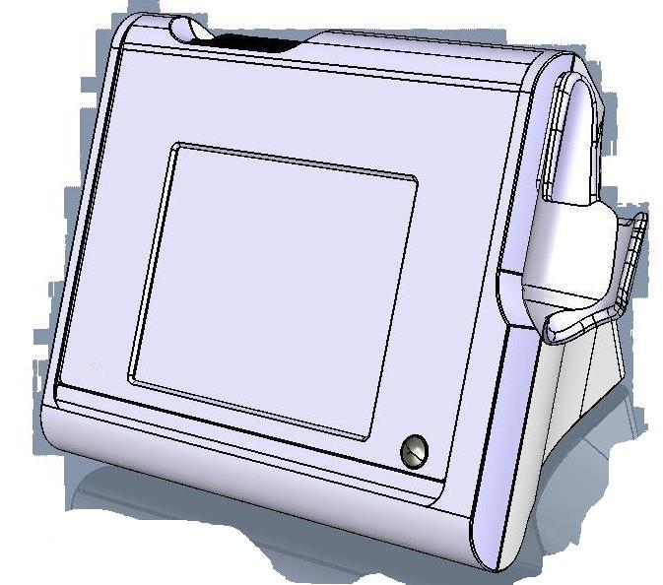

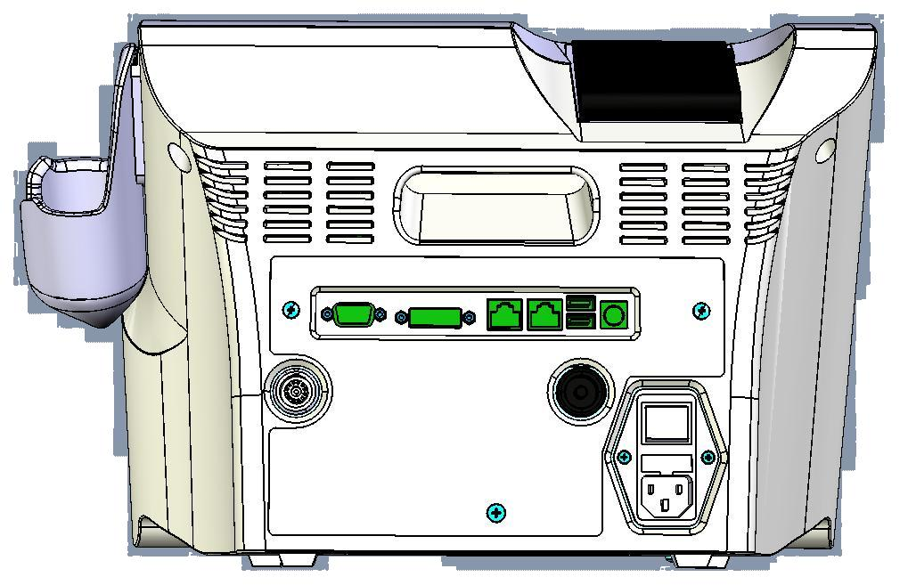

|  |  |
| --- | --- |
| Operator Code: | Signature: |