|  |  |
| --- | --- |
|  | Checking-List 502 Touch Step 1 |

|  |  |  |  |  |  |
| --- | --- | --- | --- | --- | --- |
| REF. DOCUMENT : | QF143 | | | | |
|  | Nom | | Fonction | Date | Signature |
| AUTEUR | Nicolas SOLLIER | | Technicien SAV |  |  |
| VERIFICATEUR | Nathalie LUONG | | Chargée Qualité |  |  |
| APPROBATEUR | Olivier BOSCHAT | | Responsable SAV |  |  |
|  | | | | | |
| DIFFUSION : | | ECHOSENS, DISTRIBUTEURS | | | |

|  |  |  |  |
| --- | --- | --- | --- |
| MODIFICATIONS : | | | |
| Date | Indice | Nature de la modification | Par |
| 11/12/13 | 1 | Création du document | KC |
| 20/11/15 | 2 | Mise à jour des incertitudes de mesure pour harmonisation avec le manuel technique  Mise à jour de l’adresse | KC |
| 15/06/2017 | 3 | Ajout des valeurs de test électrique | OB |
| 30/10/2017 | 4 | Remise en forme des informations produit  Suppression des tests liés au Wifi/Bluetooth (suite au retrait du module correspondant)  Ajout des parties « Probe 2 » et « Probe 3 »  Ajout d’une cartouche de signature à la fin du rapport | NSO |

|  |  |  |
| --- | --- | --- |
| Form REF. | QF143.4_SOP QP052 | 3 pages |

|  |  |  |  |  |
| --- | --- | --- | --- | --- |
| **Product Informations** | | | | |
| **S/N** | **F60342** | **Man. /Dist.** |  | |
| **Probe S/N** |  | **S90361** | | **S71983** |
| **Customer location** | **SANTIAGO** | **Customer name** | **PONTIFICIA UNIVERSIDAD CATOLICA** | |

|  |  |  |  |
| --- | --- | --- | --- |
| **Service location** | Echosens  On site ………………………………  Other :  **CENCOMEX** | | |
| **Service date** | **16 / ENERO / 2019** | **Service reference** | SR/ |

|  |  |
| --- | --- |
| **Technical Note Applicable** | |
| 27-Main Filter Enhancement | OK  NOT OK Comment: |

|  |  |  |
| --- | --- | --- |
| **Software** | | |
| Update software | OK  NOT OK  N/A | Software version = **C3,2** |
| Check Log files | OK  NOT OK | |
| Check import/export data | OK  NOT OK | |
| Check of Excel backup | OK  NOT OK | |

|  |  |  |  |  |
| --- | --- | --- | --- | --- |
| **Used instruments** | | | | |
| **Manufacturer** | **Model** | **Description** | **MET (Echosens only)**  **Or S/N (for distributors)** | **Calibration due date** |
|  |  |  |  |  |
|  |  |  |  |  |

|  |  |  |
| --- | --- | --- |
| **Computer Area** | | |
| **Mother board D2703 voltage, connector 17** | | |
| **Connector description** | **Value obtained** | **Result** |
| Pin 18: + 24 Vdc ±1,20Vdc |  | OK NOT OK |
| Check of the connectors | OK  NOT OK | |
| Disk drive test | OK  NOT OK | |

|  |  |  |  |
| --- | --- | --- | --- |
| **Power Supply Area** | | | |
| Power supply type | |  | |
| **Connector description** | | **Value obtained** | **Result** |
| Mother board connector | Pin 4: + 24 Vdc ±1,20Vdc |  | OK  NOT OK |
| Main filter | OK  NOT OK | Fuses (2A/250V)*2 | OK  NOT OK |

|  |  |  |
| --- | --- | --- |
| **Elastometry V2 Area** | | |
| **Connector description** | **Value obtained** | **result** |
| Pin 5 : - 16 Vdc ±0,80Vdc |  | OK  NOT OK |
| Pin 1 : + 16 Vdc ±0,80Vdc |  | OK  NOT OK |
| Pin 8 : + 5 Vdc ±0,25Vdc |  | OK  NOT OK |
| Pin 4 : - 25 Vdc ±1,25Vdc |  | OK  NOT OK |
| Pin 2 : + 27 Vdc ±1,35Vdc |  | OK  NOT OK |
| Check connection | | OK  NOT OK |

| **Screen Area** | | | | | | |
| --- | --- | --- | --- | --- | --- | --- |
| Test on/off button (led on) | | | OK  NOT OK | | | |
| Check the Touchpad | | | OK  NOT OK | | | |
| Test VGA output | | | OK  NOT OK  N/A | | | |
| Test USB port | Front | | OK  NOT OK Comment: | | | |
| Rear | | OK  NOT OK Comment: | | | |
| Test network output | | | OK  NOT OK  N/A | | | |
| Test of printer | | | OK  NOT OK  N/A | | | |
|  | |  | | |  | |
| **Probe 1** | | | | | | |
| Blue LEDS of the probe | | | | OK  NOT OK | | |
| Check the probe memory | | | | Date of next calibration : **ENERO 2020** | | OK  NOT OK |
| Acquisition Test | | | | OK  NOT OK | | |
| Check the information contact on calibration message | | | | OK  NOT OK | | |

|  |  |  |
| --- | --- | --- |
| **Probe 2**  **N/A** | | |
| Blue LEDS of the probe | OK  NOT OK | |
| Check the probe memory | Date of next calibration : **ENERO 2020** | OK  NOT OK |
| Acquisition Test | OK  NOT OK | |
| Check the information contact on calibration message | OK  NOT OK | |

|  |  |  |
| --- | --- | --- |
| **Probe 3**  **N/A** | | |
| Blue LEDS of the probe | OK  NOT OK | |
| Check the probe memory | Date of next calibration :……...……... | OK  NOT OK |
| Acquisition Test | OK  NOT OK | |
| Check the information contact on calibration message | OK  NOT OK | |

|  |  |
| --- | --- |
| **Class 1 Type B safety test** | |
| Date………………  Tested By……………….…..…… | Protective earth impedance = (Earth bond)  < 0,3Ω  Pass     Fail  Earth leakage current (Equipment leakage)  <500µA  Pass     Fail  Breakdown on insulation(insulation EUT 500V)   Pass     Fail |
|  | |
| IEC 62353:2008 | |

|  |  |
| --- | --- |
| **FRAME** | |
| State of device (cf. picture below) | OK  NOT OK |
| Labelling | OK  NOT OK |

**FRAME CONTROL**

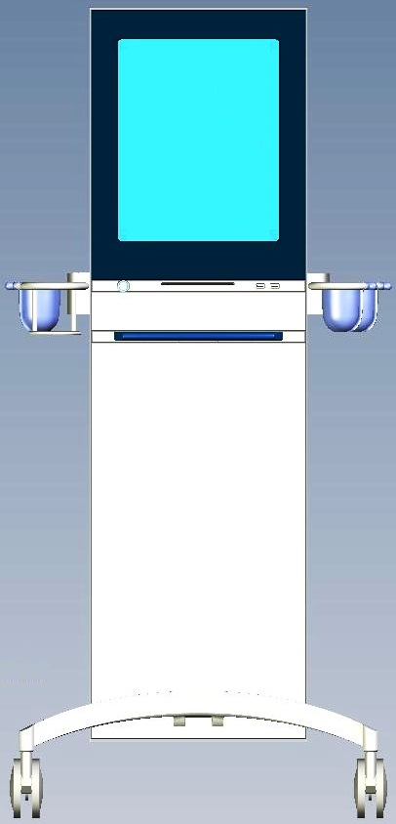

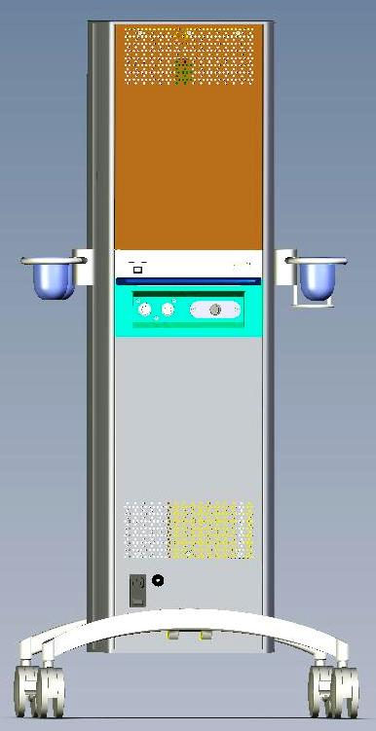

|  |  |
| --- | --- |
| Operator Code: | Signature: |