 | E117F009.1adjusting HALL in 3G probes

1. Purpose 2
2. Equipment used 3
3. adjusting and wiring oscilloscope and generator 3
4. adjusting and wiring multimeter. 3
5. Méthod 4

Purpose

Adjust electrodynamic transducer hall effects so that « X0 is incorrect » is corrected

Equipment used

Oscilloscope and voltage generator

adjusting and wiring oscilloscope and generator
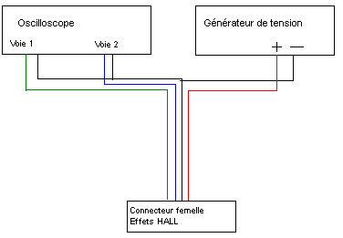

Adjust oscilloscope as follow :
- Channels 1 and 2 1v per div
- timebase 10µs per division.
- Use math function (channel 1 minus channel 2).

Voltage generator has to supply 5,00Volts.

adjusting and wiring multimeter

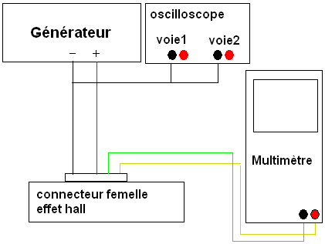
Adjust as follows :

- Channels 1 and 2 1v per div
- Timebase 10µs per division.
- Use math function (channel 1 minus channel 2).
Grounds have to be common.
- + side of channel 1 and 2 have to be connected to multimeter.
- multimeter adjusted to 2V.

Voltage generator must supply 5,00Volts.

Méthod

Disconnect HALL effects elements (see picture) and plug it to the female connector,linked to oscilloscope and voltage generator

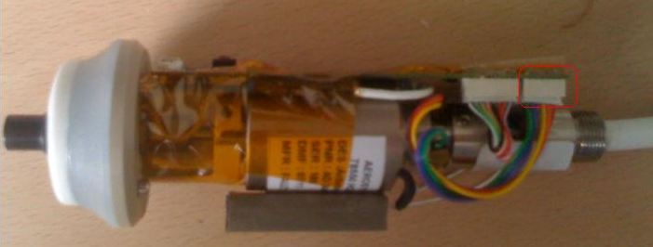

Unscrew and rotate the ring from the HALL (see picture) in order to have an output voltage channel 1 – channel 2 between 1,40 Volts et 1,55 Volts.

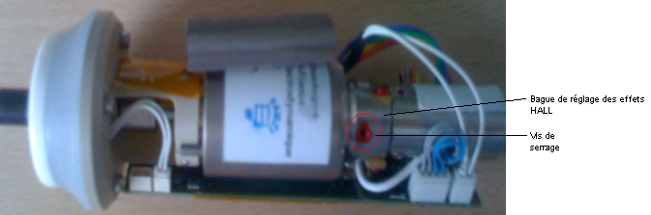.
In some occasions the little electronic board can prevent the adjustment, unscrew it slightly and move it

