# Elastography Engine TroubleShooting

**Hardware Error**

**Elastography Engine**

**Hardware Error**

**IEEE 1394 problem**

There are two main reasons which can explain a “hardware error”:

* A problem on the elastography engine
* A connection issue on the IEEE1394 link

Follow the steps bellow to identify the origin of the problem.

Are the diodes indicating an error on the Elastography Engine?

* if yes, the problem is identified, go to step 1.2
* if no, go to step 2

## Step 1.2

## Step 2: IEEE 1394 cable verification

Check the IEEE 1394 cable.

* If the cable is disconnected, go to step 5.
* If not, go to step 3

## Step 3: Elastography Engine verification

### Materials

This step requires

* A laptop with IEEE1394 (firewire) port or an extension card.
* Custom IEEE1394 cables for
  + Fibroscan 502 STEP
  + Fibroscan 502 TOUCH

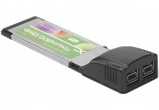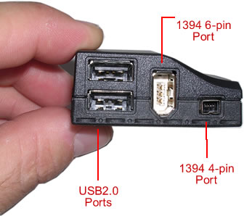

IEEE1394 ports exist in 2 formats: 4-pin and 6-pin

Botton : custom IEEE 1394 cable

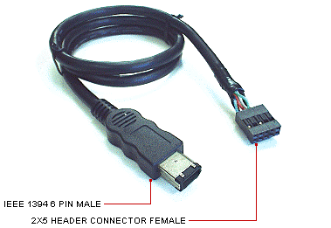

* Turn OFF the Fibroscan
* Open the Fibroscan
* [FBS502TOUCH] Disconnect the IEEE1394 cable at the PC end
* [OTHER] Disconnect the IEEE1394 cable at the elastography engine end
* Directly connect the elastography engine to a laptop PC using
  + a standard IEEE1394 cable with PV1
  + a custom IEEEE1394 cable with PV2
  + the Elastography Engine cable with Fibroscan 502 Touch
* Turn ON the Fibroscan
* Start the hardware manager from the laptop PC

The hardware manager shall detect a new hardware and prompt to search for a driver for it.

* If the hardware manager does not detect the elastography engine, the elastography engine is not working properly, go to step 4
* If the hardware manager does detect the elastography engine, the problem is to be sought at the cable or PC side IEEE 1394 connector, go to step 5

|  |  |
| --- | --- |
| **http://flysight.ca/wiki/images/archive/0/04/20101113052047!Caution.png** | **Always turn OFF Fibroscan before connecting / disconnecting the IEEE 1394 cable.** |

Note: the windows hardware manager can be started

* From the start menu, control panel, hardware and audio
* By using the command “mmc devmgmt.msc” from the command window

## Step 4: Elastography Engine problem investigation

### Materials

This step requires a voltmeter.

* Check the power supply of the elastography engine using a voltmeter
* If the power supply of the elastography engine is correct, go to step 6
* If the power supply of the elastography engine is not correct, go to step 7

## Step 5: IEEE 1394 connection problem investigation

|  |  |
| --- | --- |
| http://t3.gstatic.com/images?q=tbn:ANd9GcRiBv4aA1O-GyiDcFY1Ub0W_gN7bIY4L066xy_ipLid8iocrSExJKyMJEnz | **Replace IEEE 1394 cable.** |

## Step 6: Elastography Engine problem

|  |  |
| --- | --- |
| http://t3.gstatic.com/images?q=tbn:ANd9GcRiBv4aA1O-GyiDcFY1Ub0W_gN7bIY4L066xy_ipLid8iocrSExJKyMJEnz | **Replace Elastography Engine** |

## Step 7: Power Supply problem

|  |  |
| --- | --- |
| http://t3.gstatic.com/images?q=tbn:ANd9GcRiBv4aA1O-GyiDcFY1Ub0W_gN7bIY4L066xy_ipLid8iocrSExJKyMJEnz | **Replace Power Supply** |