## Gluing firewire cable



**Beware of ESD instructions before manipulating pcb s**

1. Check that both mother board and connector surfaces are clean
2. – use silicone Loctite ref 5145
   1. Check that glue is not overdue

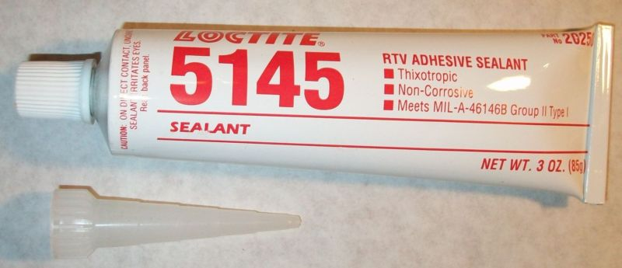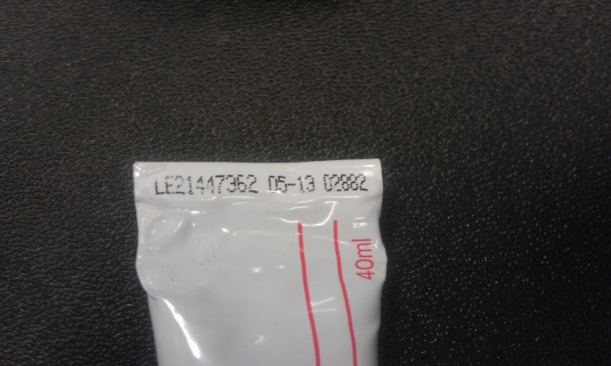

* 1. Paste a small quantity on the connector (avoid leakage on other parts)

**Gluing OK :**

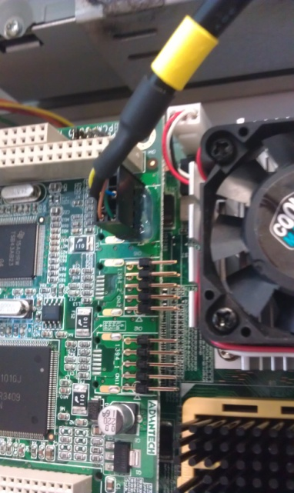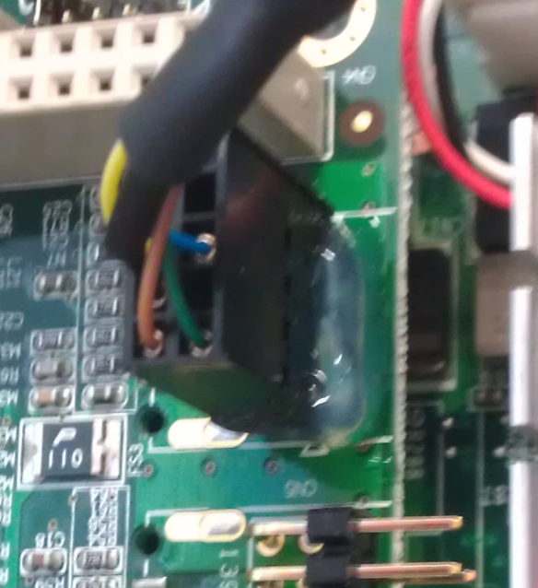

**Gluing not OK :**

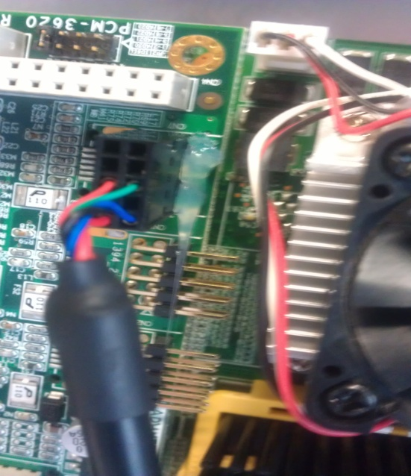

**Product is dry and efficient after 72h**

* Do not touch the cable while LOCTITE dries
* In case ungluing is needed wait 3 hours to oerate

To remove silicone



**Warning :never pull the connector to remove the glue , else you might damage it**

1 – use a small clamp and remove the glue between board and connector

²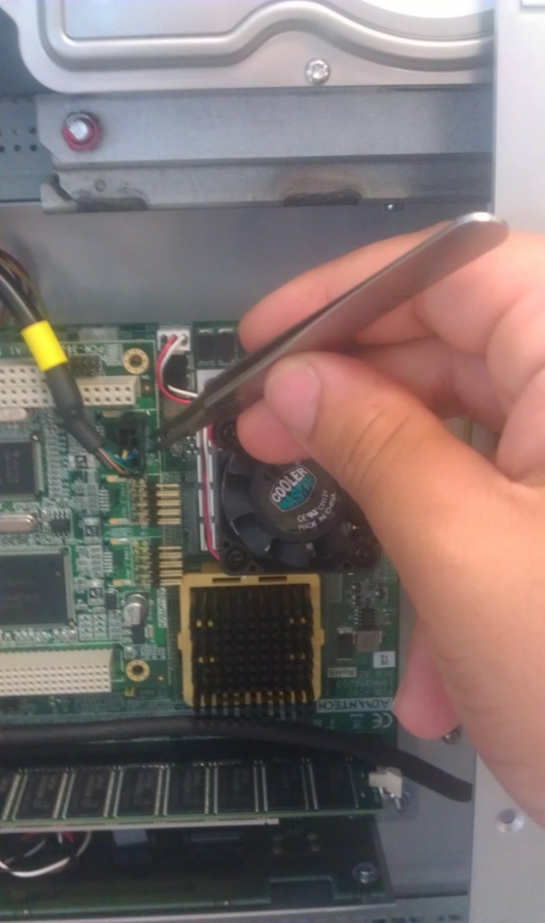

2 – gently pull the connector

And reglue as explained in the beginning

* Silicone can be stored in a fridge or in a room at ambient temp between 8°C and 21°C