Configuration LAN (Fibroscan on Network)

PC’s information necessary:

1st Step:

-In first please check your login session, write on paper or file TXT user name and memorize password

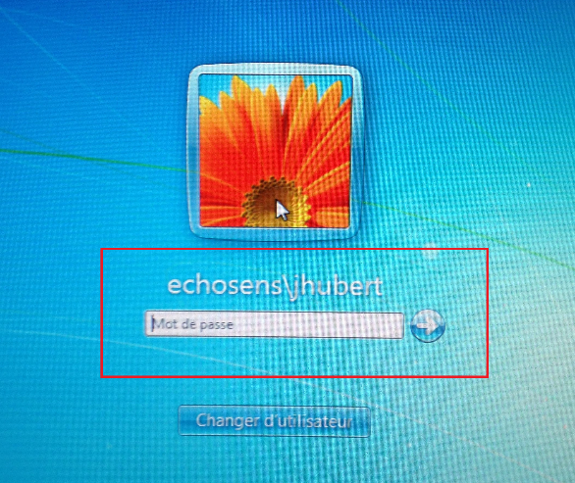

-Example: username is “echosens\jhubert”

-Click on « Start »

-Click right on Computer and select “properties”

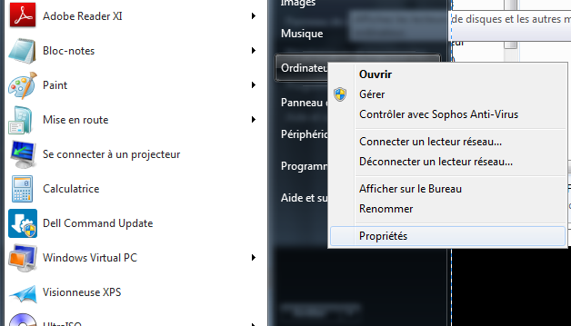

-Write on paper “Computer name” and “Network Domain”

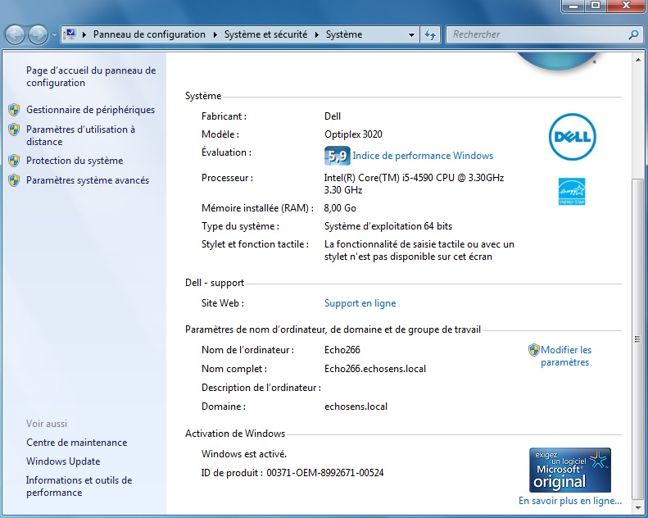

-Example: computer name is « Echo266 » and domain is « echosens »

Now you have all information necessary to configure Fibroscan as below:

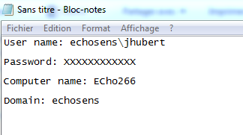

2nd Step:

-Create folder « Fibroscan » under C Disk :

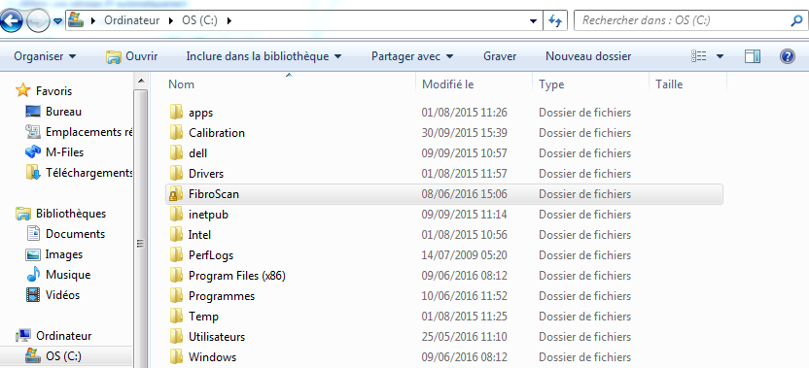

-Folder created, done a right click on this folder and select properties

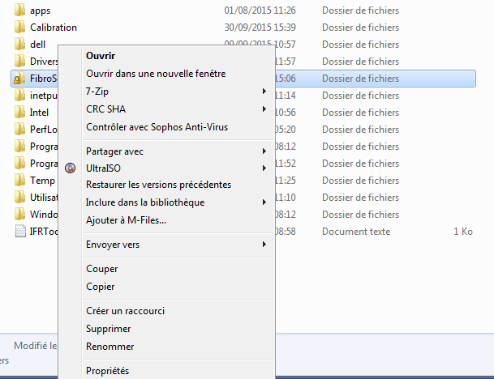

-Click on TAB « Share » then click shared

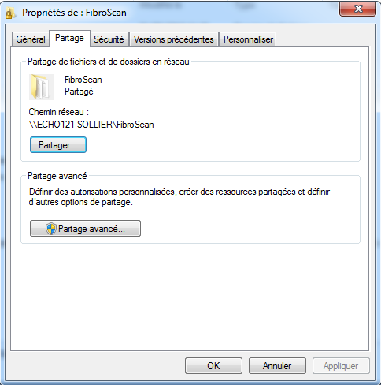

-Select your username, then click on shared

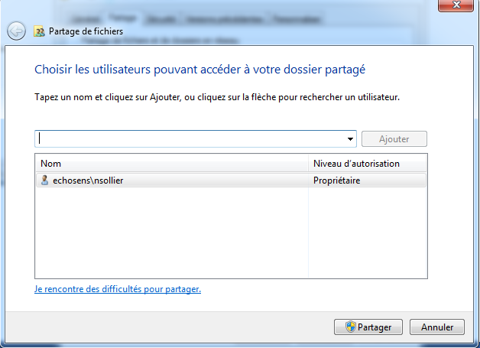

-Click on finish

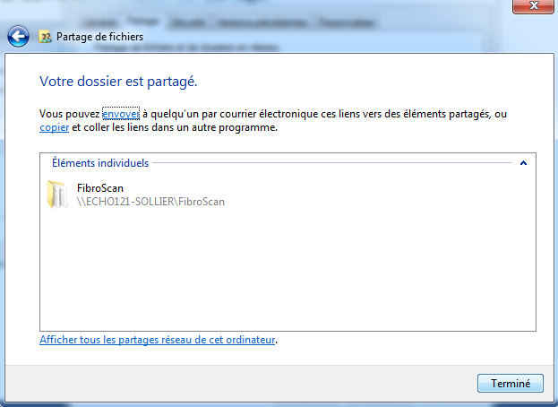

-Click on advance share



-Click on « permissions »

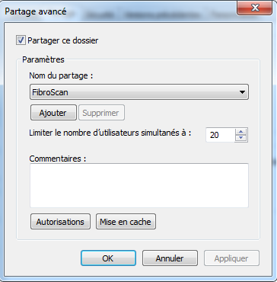

-Select « All », check « This three box » and click on « Apply »

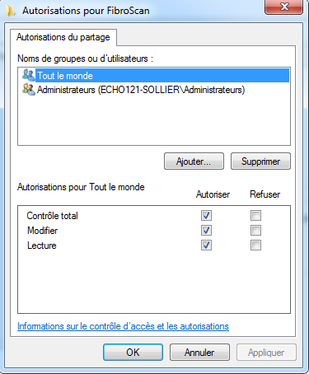

Your PC is ready for communicate with your fibroscan

Fibroscan configuration :

-Start the fibroscan and connect you Fibroscan admin Mode with Password 5UP374DM1N

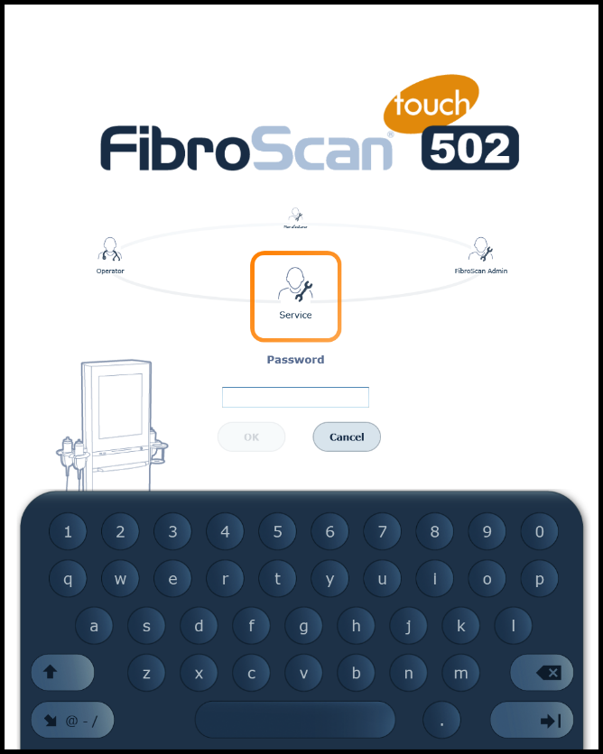

-Go on TAB connectivity and select automatic

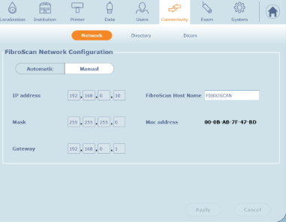

-Go to directory

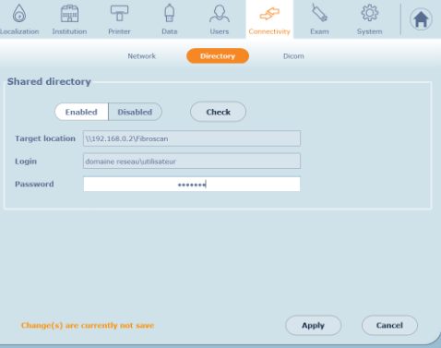

Target Directory : \\computername\Fibroscan

Example: \\ECHO266\Fibroscan

Login: Network Domain\PC name (If not Network Domain, please to put only PC’s name)

Example: echosens\jhubert

Password : Session Windows password (if not password , please to leave empty)

-Click on « apply »



-For finish, please click on « check »



-Windows appears with message « Network access succeed »

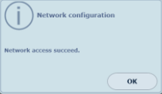

If it’s not this case, check that no error in your configuration.

Configuration test:

-Do an examen with some measure via fibroscan.

-Go on folder fibroscan on your PC C:\FibroScan

You will see your examen on your folder « fibroscan », your file fibx.

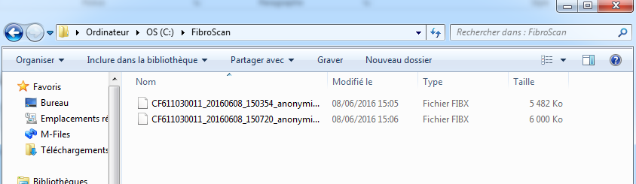

If you have some fibroscan on your network, we recommend to create under folder Fibroscan on your PC, a new folder named by the fibroscan serial. It’s better to find examen by fibroscan.

If you have some problem, please contact us by mail or phone

**ECHOSENS**

5 RUE JEAN LEMOINE

94000 CRETEIL – France

T: +33 1 49 81 89 29

M : [service@echosens.com](mailto:service@echosens.com)

[WWW.ECHOSENS.COM](http://www.echosens.com/)