February 05, 2019

# TO WHOM IT MAY CONCERN:

This letter will certify that –

**CENCOMEX, S.A.**

**Avenida Galvarino #7640**

**Parque Industrial Aconcagua**

**Quilicura, Santiago Chile**

# is the sole Authorized Rauland-Borg Distributor for our products for the Chile market area.

As the sole Authorized Rauland Distributor, **CENCOMEX, S.A.**, may represent itself as such, and is entitled to supply, install, and service our products, and have full warranty privileges.

If you have any questions concerning our distribution policies, please contact us at our Corporate Office in Mount Prospect, Illinois.

Sincerely,

# RAULAND-BORG CORPORATION

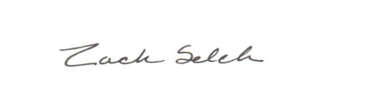

Zach Selch

Director of International Sales

GSM+1 630.347.9757