Clinica Vespucio Project

Physiotherapy Gym

View from floor to ceiling

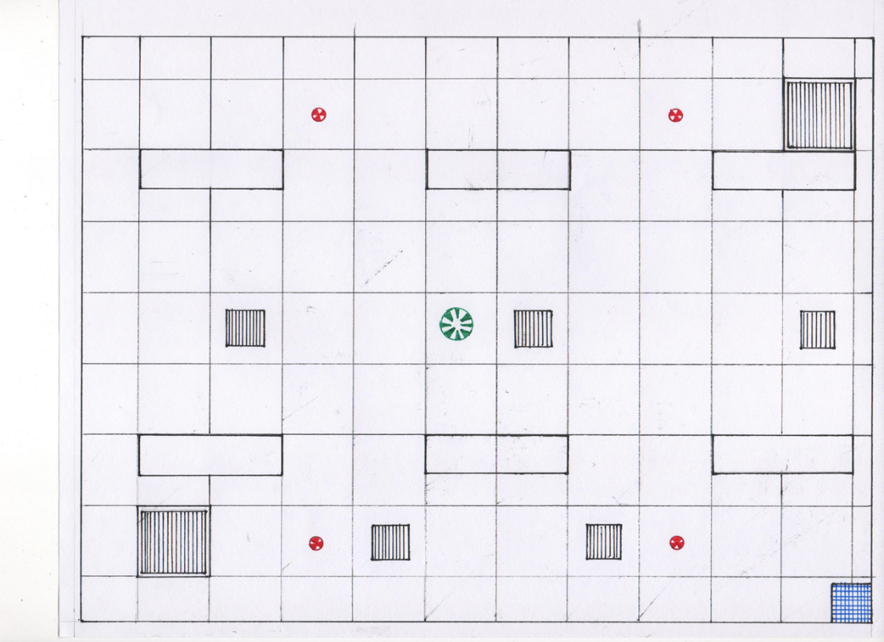1:50 h: 2,5 mt Δ: 0,46 mt

Red circles are sprinklers

Rectangles are lights

Little squares are air filters

Smoke detector

Squares are air changers

6,65 mt

4,92 mt

Shaft (plasterboard corner)

Project

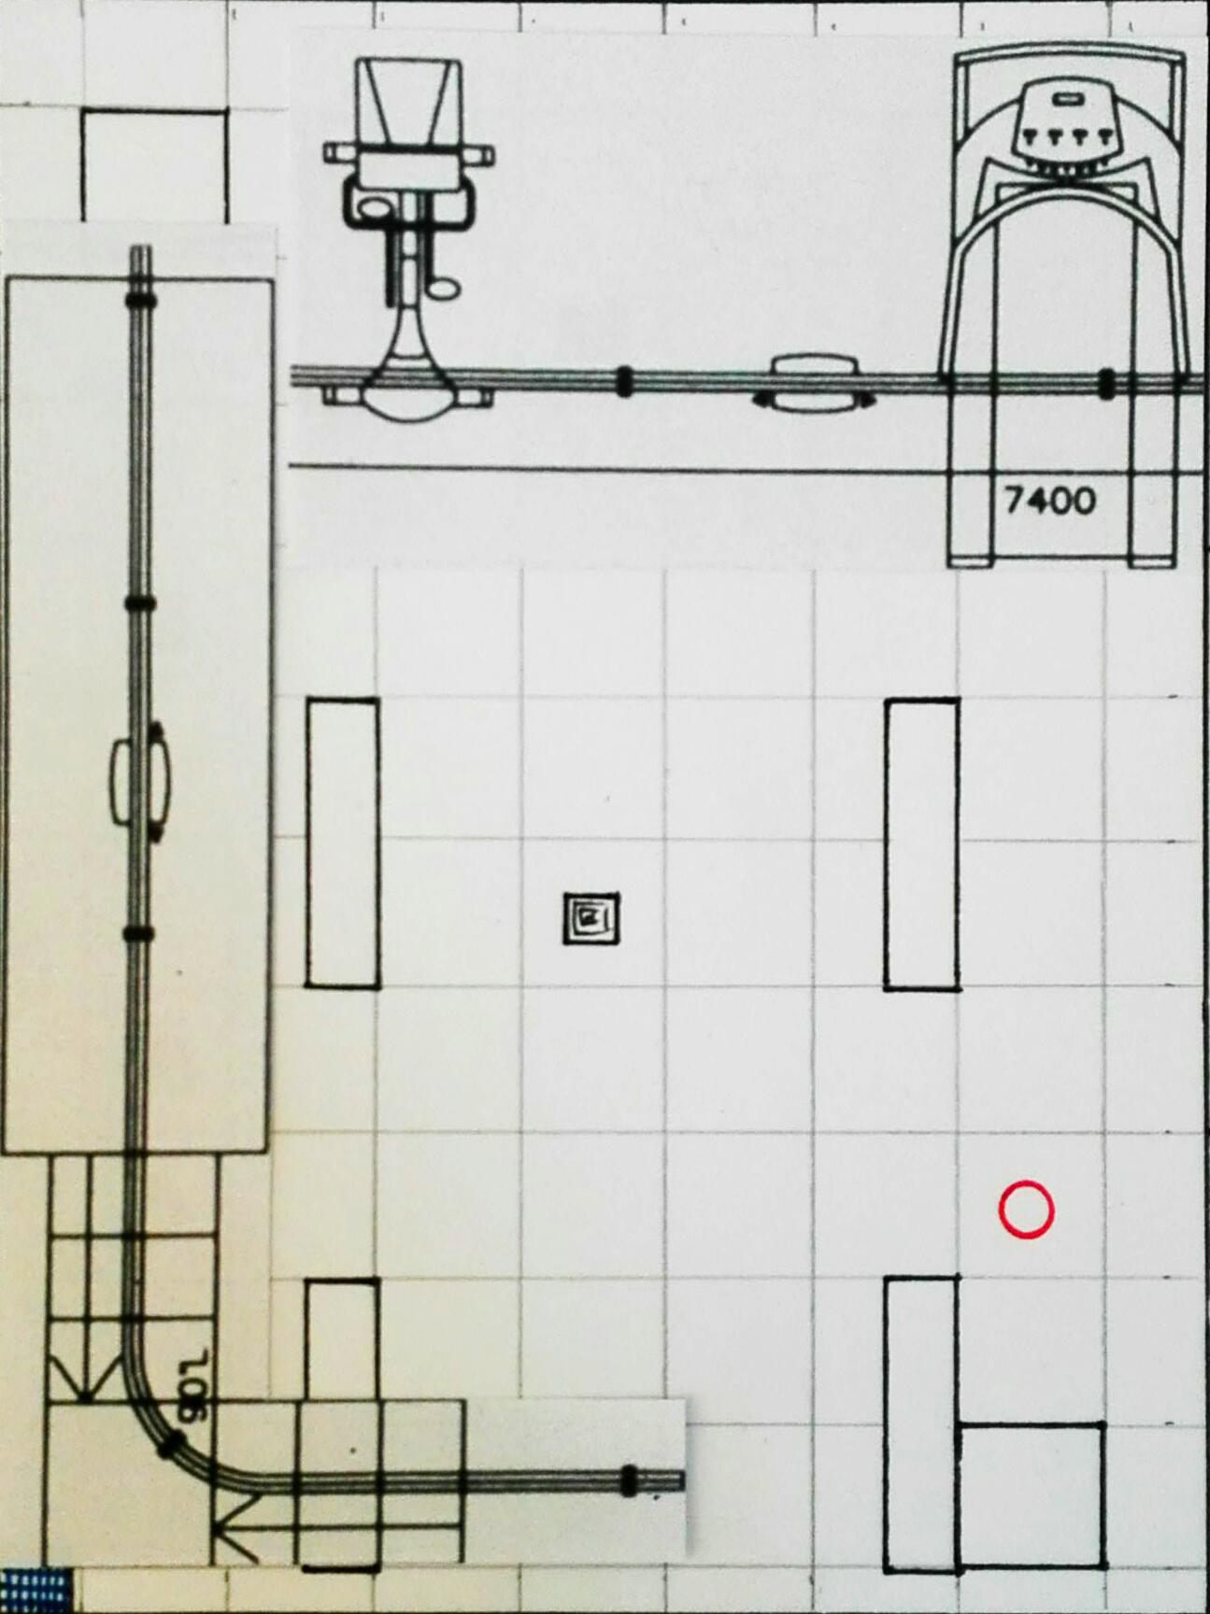

A Rail 4 mt, fixed

Fixing points (3)

A rail 4 mt, to continue the curve

Fixing points (3)

Curve 90°

Fixing points (3)

A Rail, 1 mt

Fixing points (2)

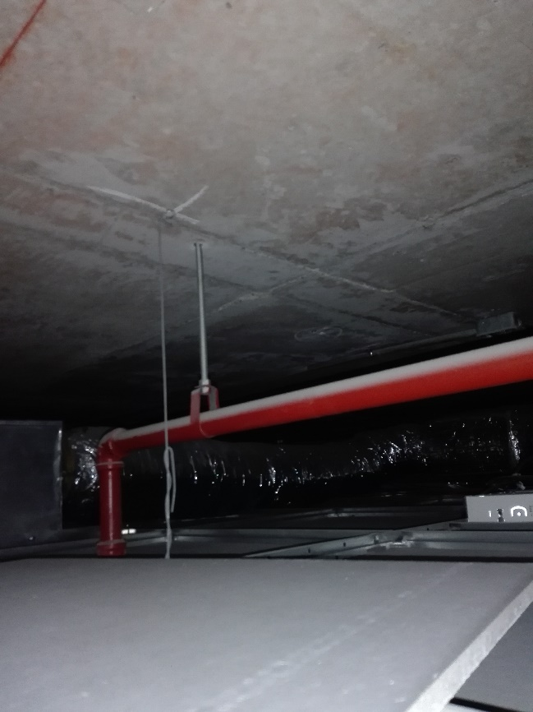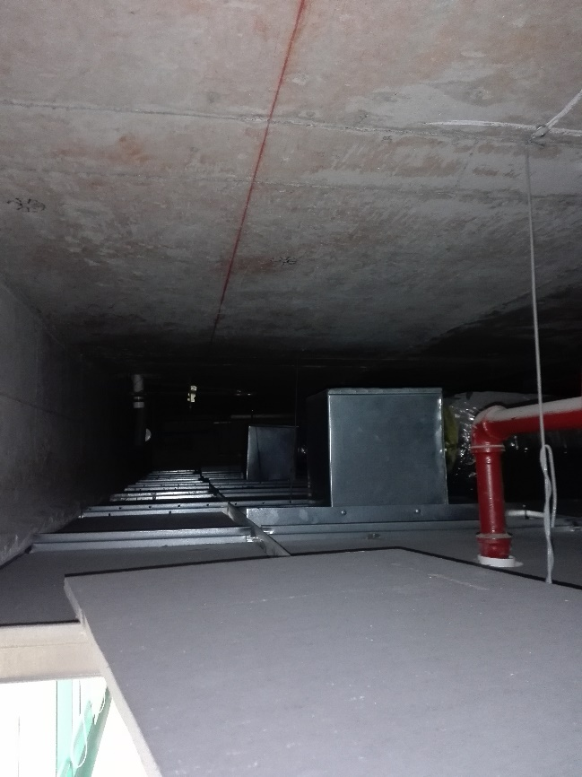Ceiling, open from the plasterboard corner, Δ: 0,46 mt

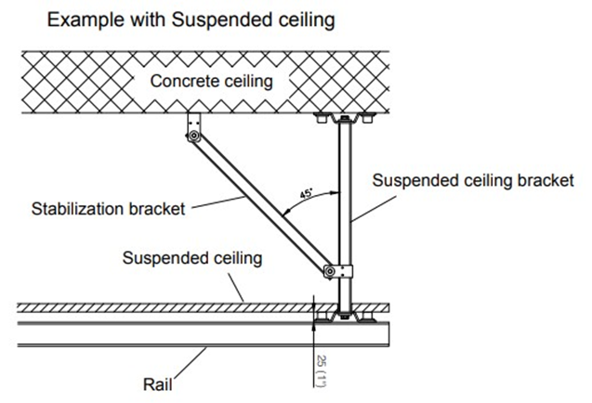Note the suspended bracket must pass next to the alluminiun ceiling support, problem?

Fixing Points, grey are suspended brackets, blue are stabilizators (Curve and large A rail will be installed left to sprinklers, sorry the picture, must be corrected) Note the lights, i hope dont have problem with this)

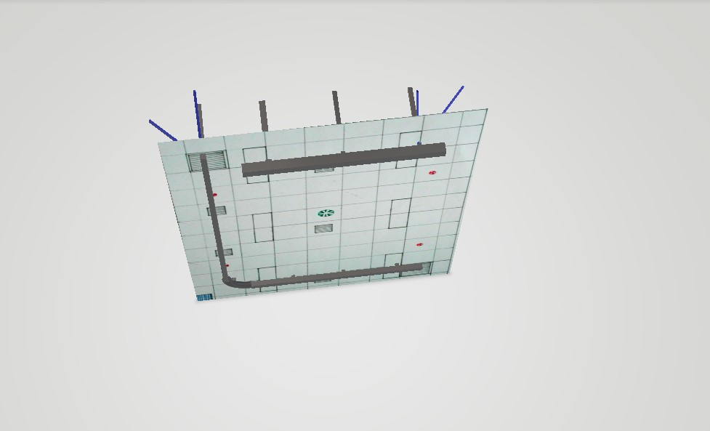

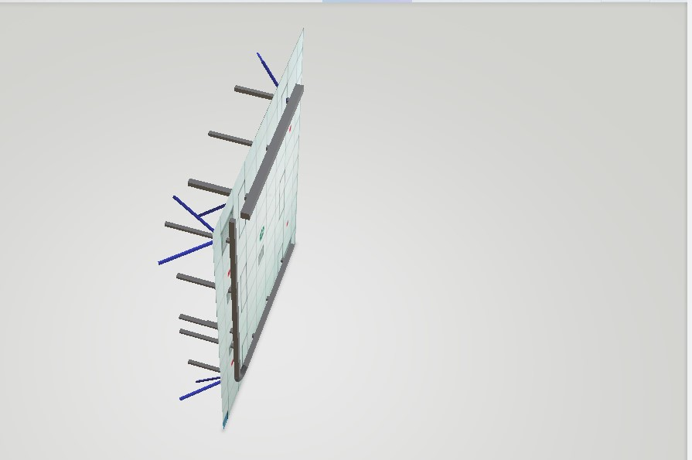

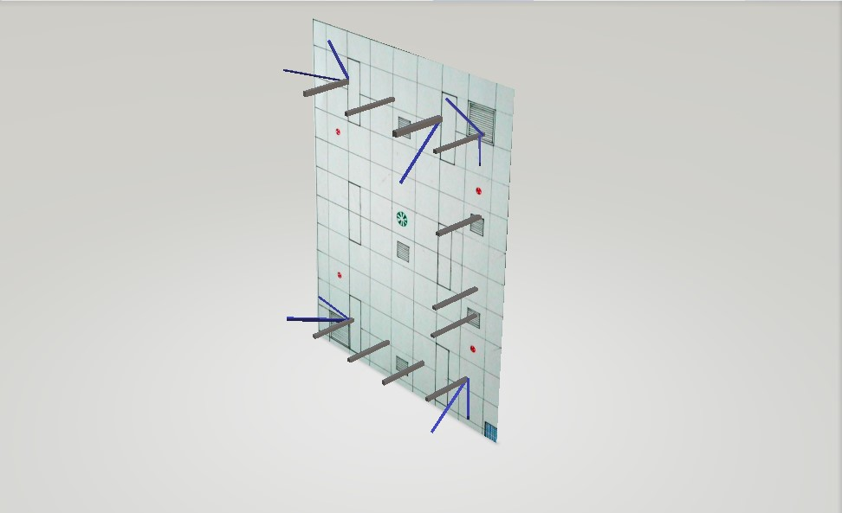

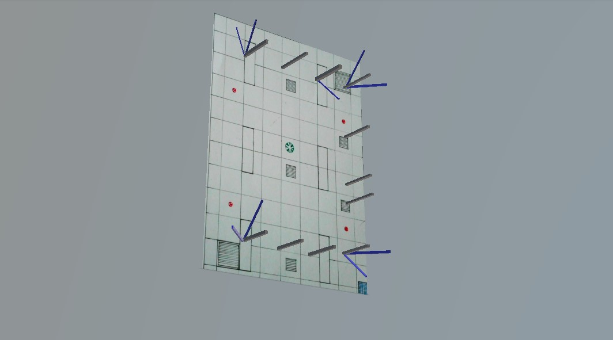

Parts

|  |  |  |
| --- | --- | --- |
| **Código** | **Descripción** | **Cantidad** |
| 552123 | GH3+ 250 kg scale CLM | 2 |
| 550354 | Riel A 4Mt c/line | 2 |
| 550351 | Riel A 1 mt c/line | 1 |
| 550025 | Curva 90° 2x2 mt | 1 |
| 550405 | Soporte STD 500 mm | 11 |
| 550418 | Stabilizing Bracket | 8 |
| 556890 | Hanger 2016 M | 2 |
| 554904 | Hanger 4 pt 250 kg | 1 |
| 283051 | Active Trainer M | 2 |
| 283111 | Active Vest Kids 6-10 | 2 |
| 283100 | Active Bariatric | 1 |
| 12330 | End stop | 4 |
| 550193 | Roseta 30mm | 11 |
| 550447 | End Cover A | 4 |
| 556002 | GLS5 active lifter | 1 |
| 28336 | Standing Sling S/M | 1 |
| 28338 | Hip Support one size | 1 |
|  | Anclaje Hilti KwiK TZ | 30 |

Thanks!